ASSIGNMENT – 2 NAME: TAMIZHARASAN K

NM ID: au611220104161

Upload the given data which is in csv format into an IBM cognos analytics

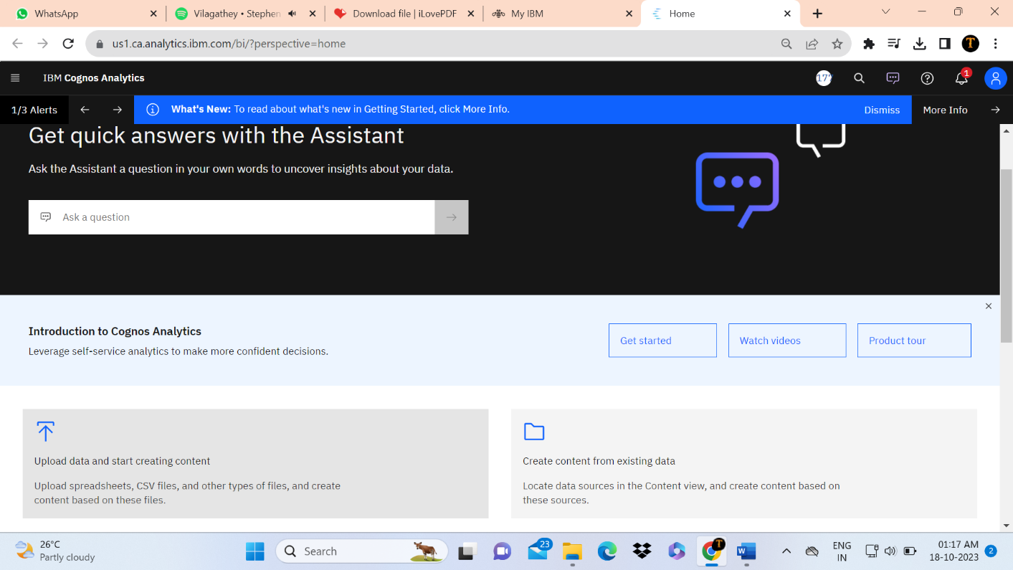

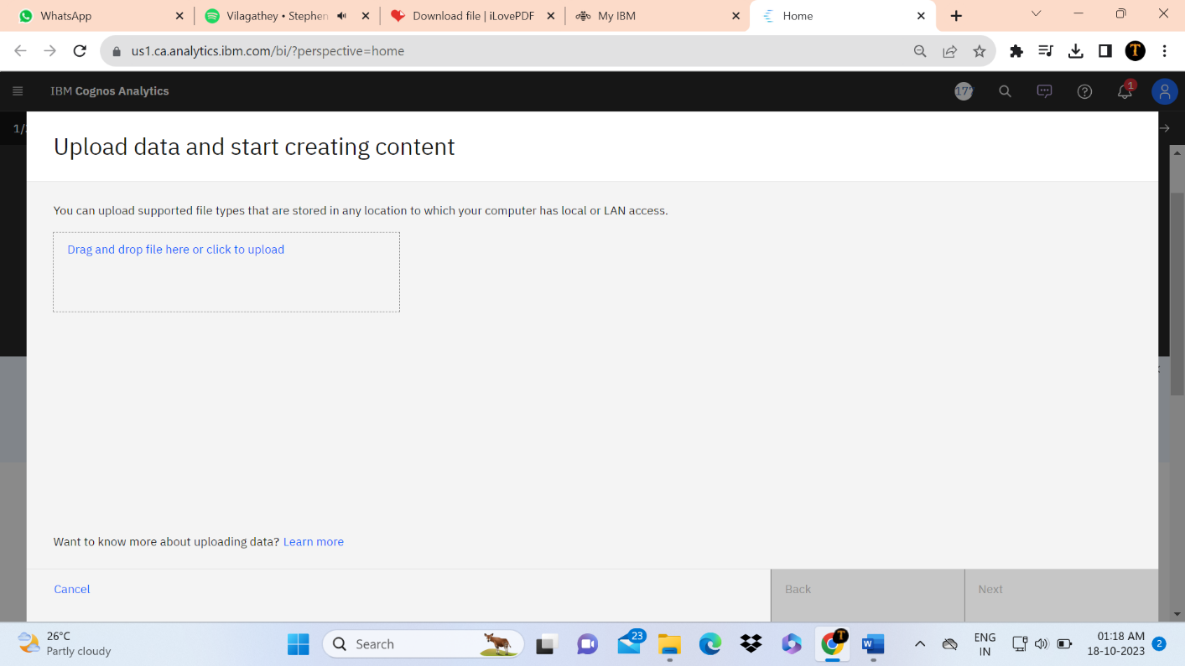

Then prepare the given data

Remove the unnecesary attributes in the data set.then save that file.

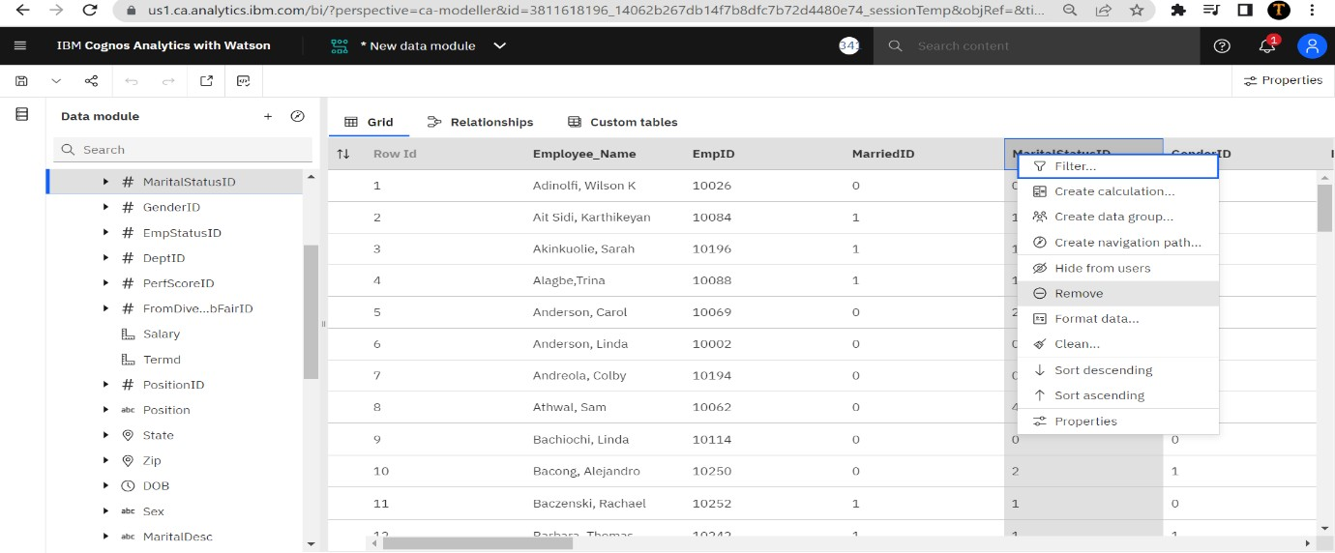

Then enter to exploration of data

We explore data as per we need

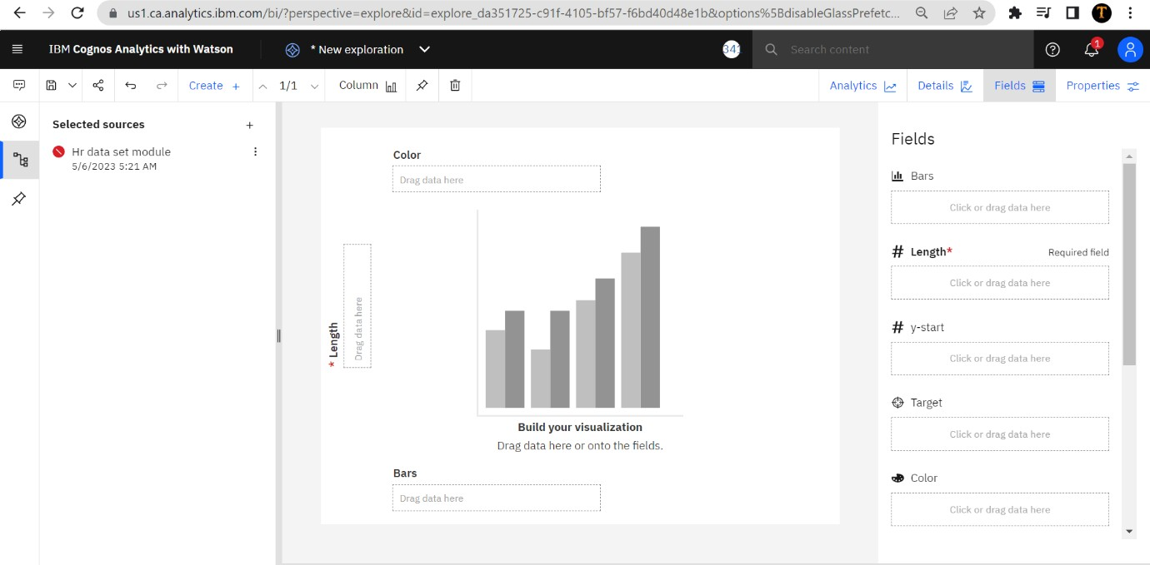

For example here we create a pie chart for exploring

the data . here we need to add the neccesary attributes in the fields.

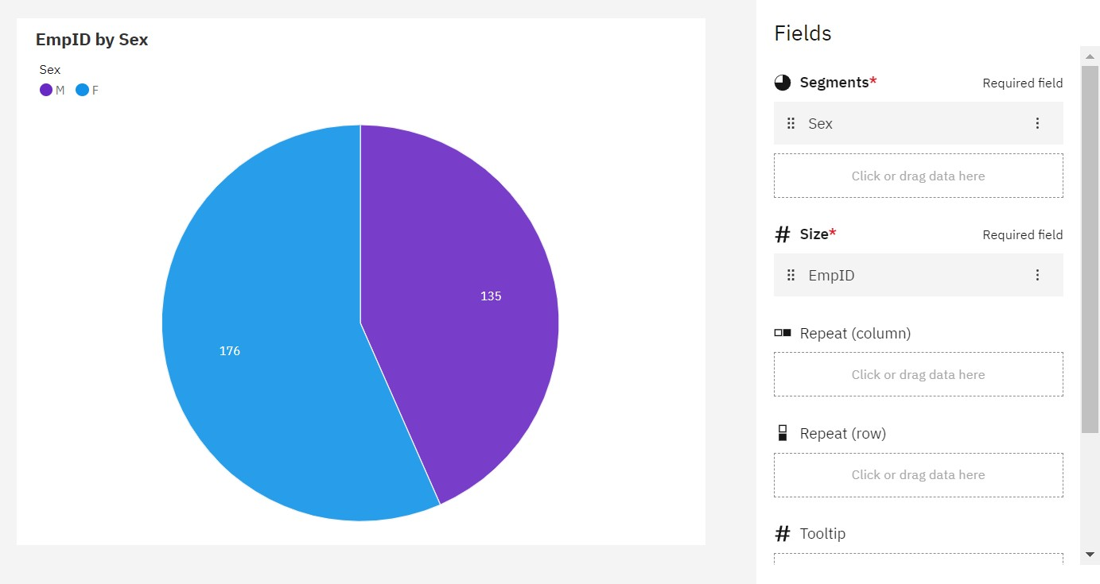

After exploring the data we get into the final phase which is presenting the data and visualize the data.

We visualize the data on presenting the data .Here we

create the in three types which is dashboard,report and story.

DASHBOARD :

Gender based Analysis and Position based analysis

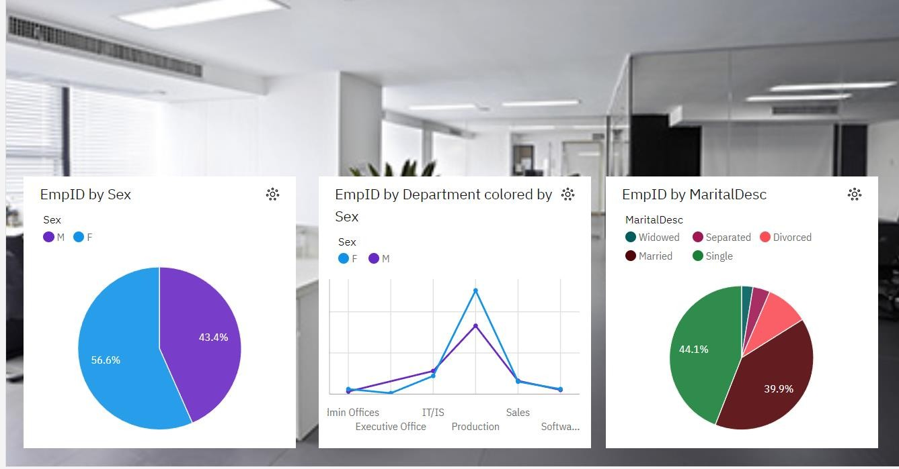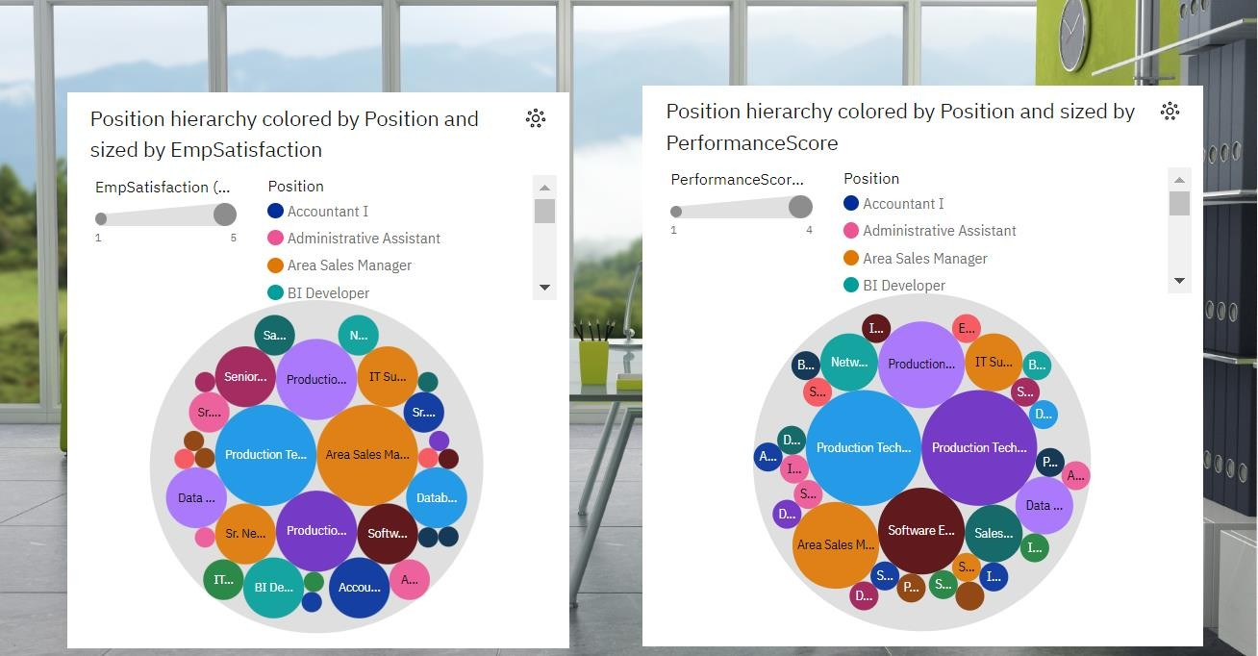

Performance, salary analysis and Recruitement analysis

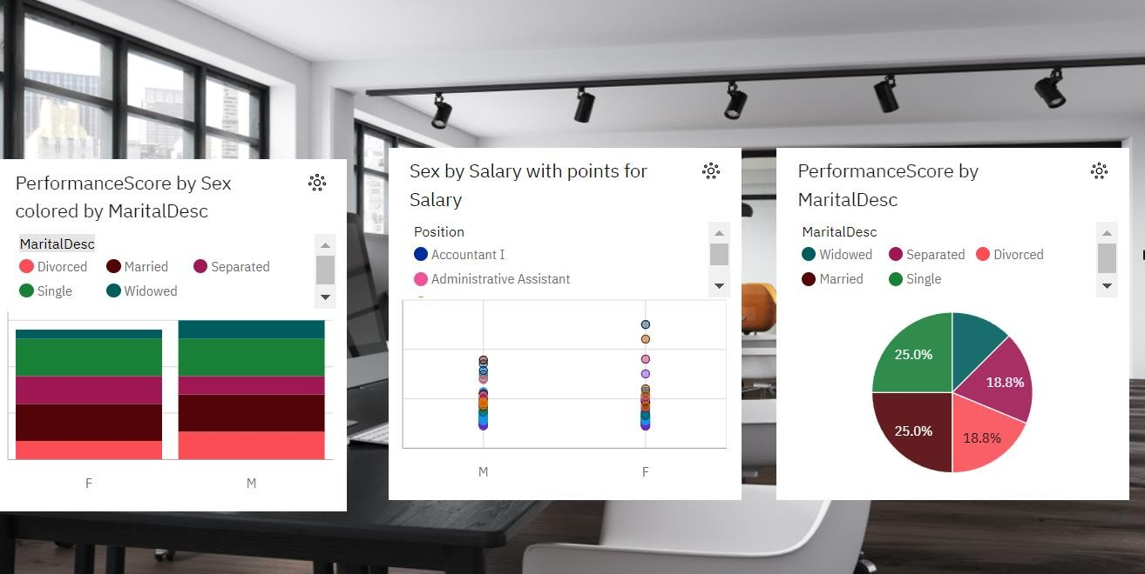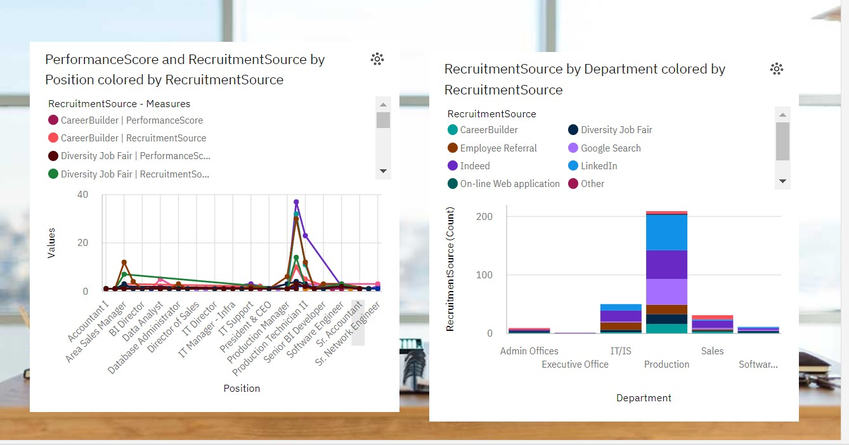

State wise requirement analysis and special project wise analysis

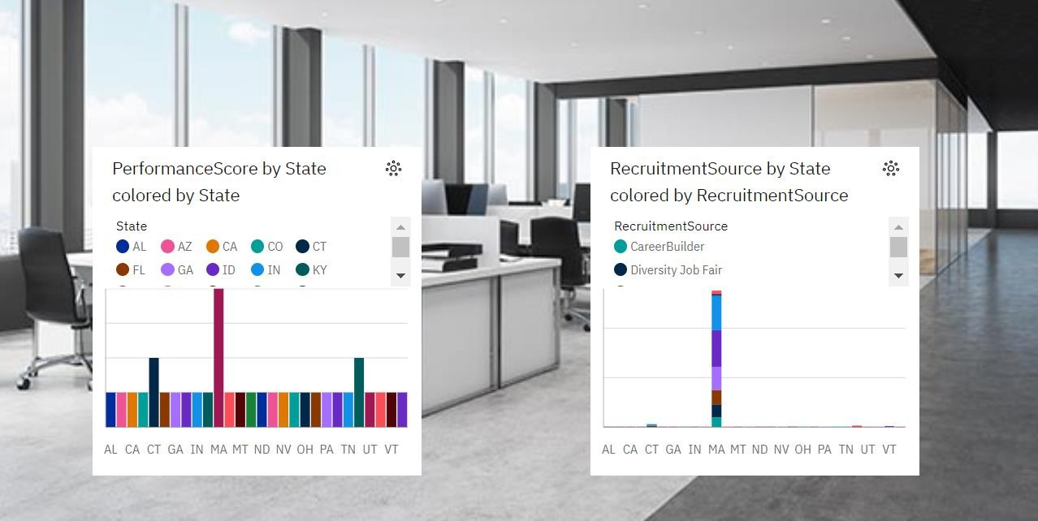

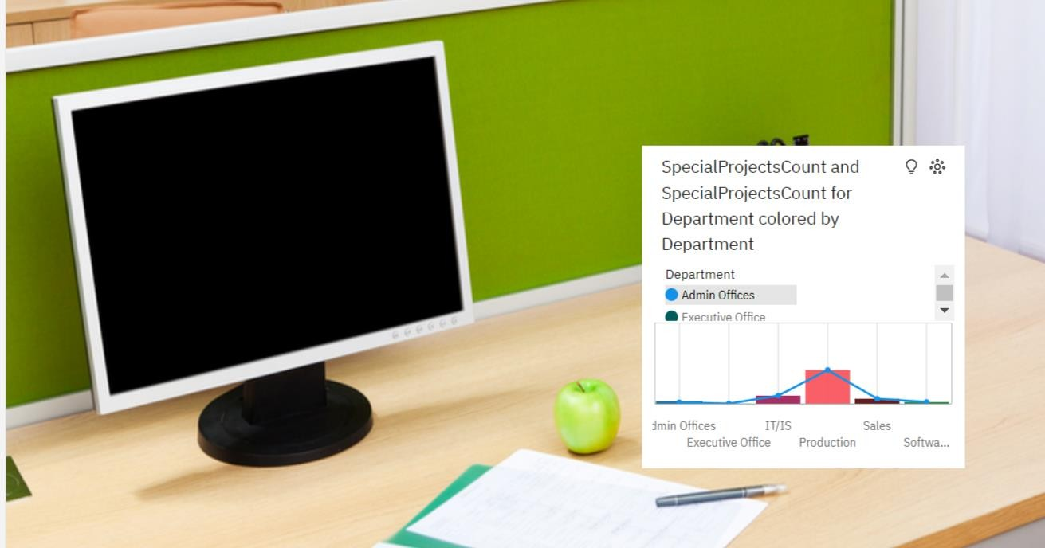

REPORT:

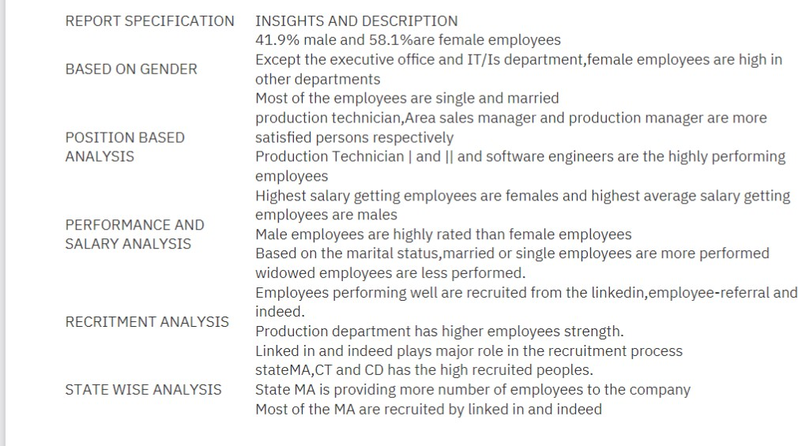

STORY:

